Kissaki-Kai Karate-Do

France

Valuing the Original Purpose of Martial Arts
Kissaki-Kai France
50 Chemin des Aires
34600 Bédarieux
France

vincemorris@kissaki-kai.com
eva@kissaki-kai.com
We uphold the values and principles of the original purpose of the martial arts; to empower members with the ability to defend themselves, their families and the weak, and to foster the development of steadfastness, courage and integrity.
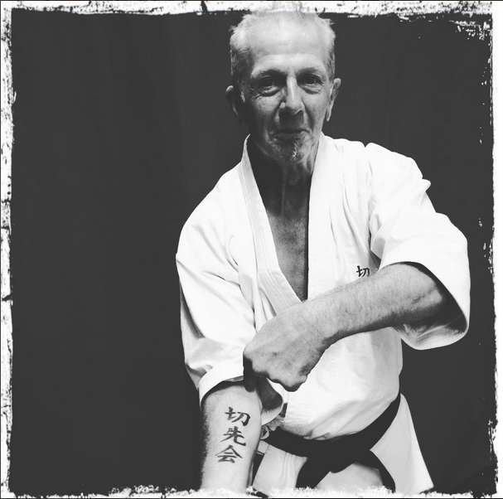

Kissaki-Kai Autumn Camp

7,8 September 2024

Bedarieux, France,

Saturday 7 September
- Session 1: 10.00h – 12.00, Session 2: 12.30 - 15.00hrs:
Dojo 2000, Stade Réné Char, Chemin des Horts et Prats,
34600 Bédarieux

Sunday 8 September
- Session 3 : 10.00h-13.00hrs: Training
Dojo 2000, Stade Réné Char, Chemin des Horts et Prats,
34600 Bédarieux

Prices
Training only: Kissaki members: €50 for the weekend or €20 per session. Non members €125 for the weekend or €45 per session.

Booking
To reserve your space please return the form below. No deposit required. Just pay when you get here.

Accommodation
We have reserved self-catering apartments (gites), 5 minutes from the dojo. Please contact us if you wish to take this option:
Campotel, Chemin des Horts et Prats,
34600 Bédarieux, from €70 per gite (sleeps 4) per night.
Having a car is a ‘must’ to get around!

Hotel de l'Orb, Parc Phoros, Route de Saint Pons, 34600 Bédarieux,
33 (0) 4 67 23 35 90 - https://www.hotel-orb.com

Local airports by distance to Bédarieux
Béziers (45 mins), Montpellier (1hr 15mins), Carcassonne (1.5hrs), Perpignan (2.5hrs), Toulouse (2.5hrs), Barcelona (3hrs)

Kissaki-Kai Karate-Do
France

Registration Form for the
Kissaki-Kai Autumn Camp in France
7,8 Sept 2024
Name(s) + Address:

___________________________________________________________________________

___________________________________________________________________________

Contact details (mobile phone, e-mail):

___________________________________________________________________________

Arrival date: ____________________________ Departure date: ____________________________

N° of persons attending entire seminar: ______ or: N° of persons attending session 1 : ______

N° of persons attending session 2 : ______

N° of persons attending session 3 : ______

N° of persons for Friday evening (€15): ______

N° of persons for Saturday restaurant: ______

Special requirements, comments etc.:

___________________________________________________________________________

Training only: Kissaki members: €100 for the weekend or €40 per session.
Non members: €125 for the weekend or €45 per session.

